Authorization for Electronic 1095-C Form Delivery

Click on the ‘Check Stub’ Icon on your desk top.
If you do not see the icon, you can copy and paste the link below into your web browser.

https://checkstub.northoaks.org/login.aspx

You may also find the link through Infor Global HR under the Pay & Benefits Section as shown below.
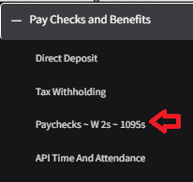

Once you get to Document Self-Service, you will need to log on using your single sign on. This is the username and password used to sign onto your computer.

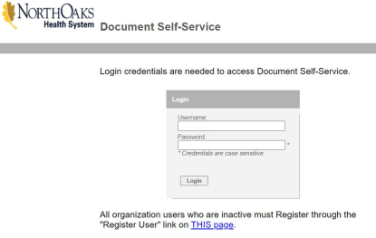
Once you are logged in, click on the ‘My Delivery Settings’ and then click ‘Web Delivery’.

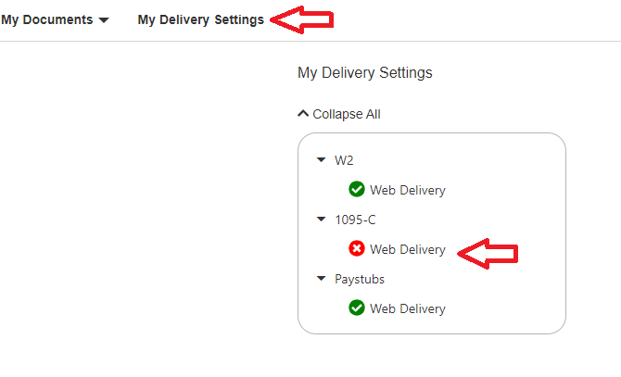

Enter your ‘primary email address' and ‘secondary email address’ then click ‘Click HERE to get authorized’.
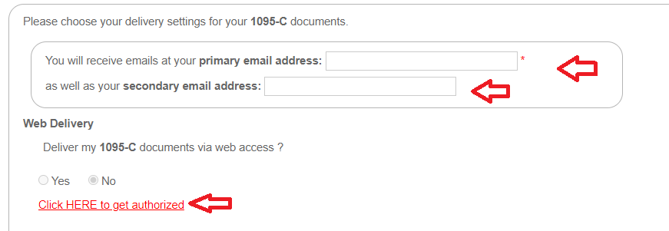

Click ‘Print Test’.

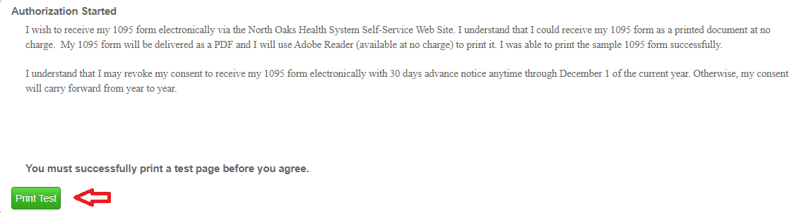

Click ‘Tax Document in PDF Format’ and print the test document, then click ‘Yes’ if you were successfully able to print the test document.

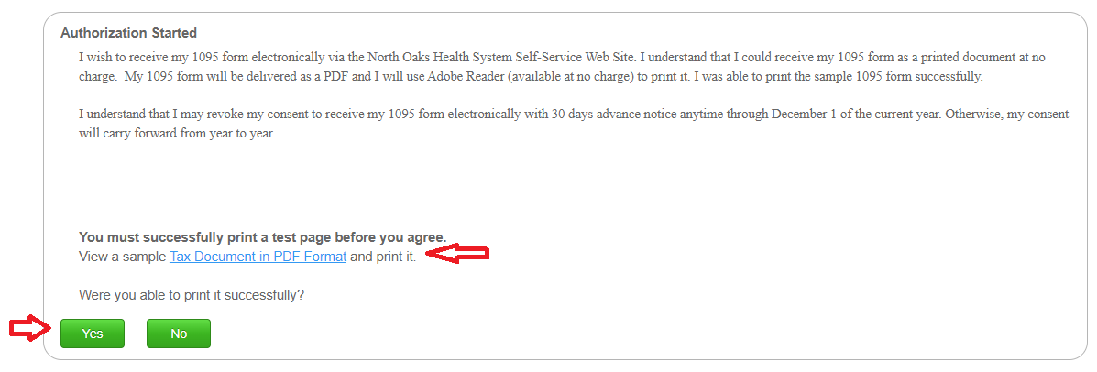

Click ‘I Agree’.

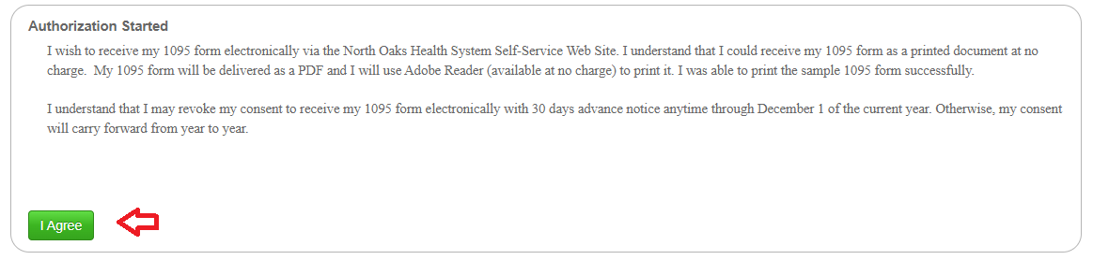

Then click ‘Yes’ and ‘Submit’.

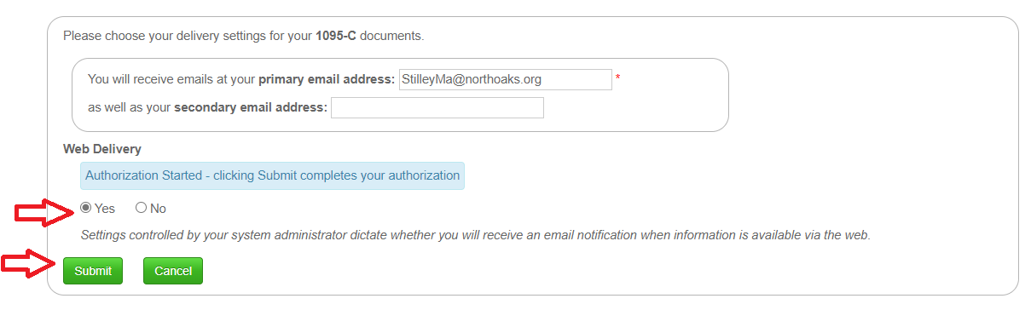

Now that you have opted to receive your 1095-C form electronically,
Your authorized form will be available to view, save, or print no later than March 2, 2026.

